Types of Composting Systems

Which One Is Right For Your Campus?
By composting your school’s fresh fruit and vegetable food waste on campus, your school can divert organic waste from landfills as well as reduce emissions from waste hauling trucks. You are also creating nutrient rich soil called humus that will reduce water use and pesticide use in your campus green spaces while producing healthy plants and gardens.

There are different systems that Grades of Green recommends for composting depending on the size and scope of your school’s campus. Below are a few popular options to consider.

Multi Bin Wood and Wire Units
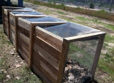
- Cost: $400 - $700
- Materials composted: fresh fruit/vegetable waste, eggshells, brown organic waste
- Waste is added to one bin at a time. When a bin is full it can rest and transform to humus as another bin is active. At all times there can be an active bin, a resting bin, and a bin of finished compost
- Notes: Easy to customize to a specific area. Can compost large amounts of food waste daily

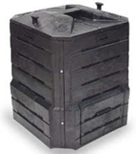
Stationary Compost Bin
- Cost: $80 -$100
- Materials composted: fresh fruit/vegetable waste, eggshells, brown organic waste
- Food waste and brown materials are added to the top and finished compost can be periodically harvested from the bottom hatch as ready
- Notes: Easy for students to access and maintain. Excess moisture will escape through the open bottom making it easy to maintain proper moisture levels. Has a limited food waste capacity and sites with large volumes of daily food waste may need more than one unit.

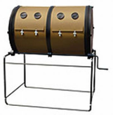
Double Sided Tumbler
- Cost: approximately $500
- Materials composted: fresh fruit/vegetable waste, eggshells, brown organic waste
- Food waste and brown materials are added to one side of tumbler at a time. When one side is full it should be allowed to rest and transform while the other side is utilized. Unit is rotated 2-3 times with handle after waste is added.
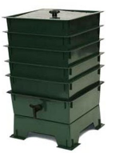
- Notes: Ratio of browns and greens must be closely maintained in a tumbler bin and too many greens/too much moisture can cause the mixture to quickly turn anaerobic. Can get heavy and may be difficult for students to close and turn.

Worm Bin
- Cost: $80 - $120
- Materials composted: Fresh fruit and vegetable scraps, newspaper, lint, egg cartons and shells
- Ideal for single classrooms, apartments, or homes without yards. Worms must be bought and placed in unit along with a bedding of newspaper. Food waste is added to top of unit to feed worms. Worm castings drop to the bottom to be utilized as fertilizer
- Notes: Requires a special type of worm that needs to be purchased. Unlike other compost units, worm bins should be kept in a shaded area out of the sun. Can handle only a limited amount of food waste.

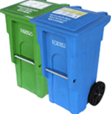
Off Site Composting
- Cost: dependent on services offered by the school’s waste hauler
- Materials composted: all food waste and paper products
- Food waste and paper products can be added directly to food waste carts that will be collected by the waste hauler and taken to an industrial compost facility to be composted
- Notes: this system can only be used with the assistance of the waste hauler that provides composting service. Because food will be composted in a high heat, industrial facility, all food waste including meats, fats, grains and dairy can be composted.

