On Site Campus Composting Overview

What is Compost?
- Composting is nature’s way of recycling plant and food waste
- Leftover food scraps, leaves, and yard trimmings can easily be broken down into humus through the composting process, creating a mixture that is rich in plant nutrients and beneficial organisms
Why is Composting Important?
- Composting helps to reduce the amount of waste that goes into our landfills and creates nutrient-rich humus that can be used in campus gardens and landscaping
- This humus benefits garden soil by adding nutrients and retaining moisture, thereby reducing the need for fertilizers and water

Composting Requirements: The composting process requires a balance of “greens”, “browns”, moisture, air, heat and scavenger bugs to work properly.

Compost Ingredient | Sources | What it Does
“Greens” | Fruit and veggie scraps  Fresh plant and grass trimmings  Eggshells  Coffee grounds | Nitrogen source for the composting process and provides the protein that microorganisms need to break down the carbon food
“Browns” | Leaves  Landscape trimmings  Sawdust  Woodchips  Shredded newspaper  Cardboard  Unbleached paper towels | Carbon source for the composting process and should be added at a 2:1 ratio to greens
Moisture | Water from a hose, bucket or watering can | Helps with decomposition and regulates the compost’s temperature  To optimize the composting process, the compost mixture should be kept as moist as a wrung-out sponge
Oxygen | Mixing or turning the compost pile with a shovel | Supports the populations of scavengers and decomposers
Heat | Sun  Increasing nitrogen-rich ingredients, such as the “greens” | Activates compost bacteria, destroys seeds and potential weeds, and accelerates the decomposition process
Scavenger Bugs | Worms  Pill bugs  Millipedes | Act as decomposers by eating and breaking down the greens and browns into smaller pieces

The Science Behind Composting
Composting occurs as components work together to create an ideal environment for scavengers and bacteria to decompose materials.
Greens (nitrogen-based) provide the protein that microorganisms need to break down the carbon food

l

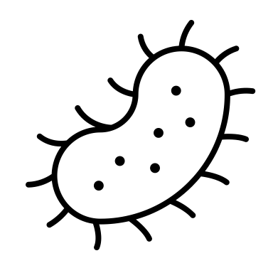
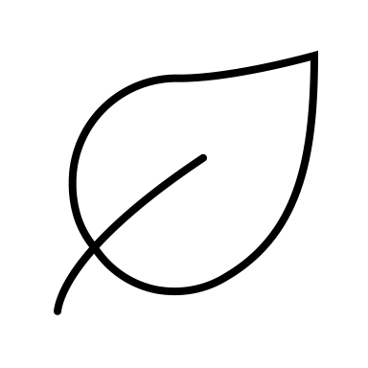
Water helps with decomposition and regulates the compost’s temperature

Heat activates compost bacteria, destroys seeds and potential weeds, and accelerates the decomposition process
l
Browns (carbon-based) provide the energy food for microorganisms in the compost pile
l
Scavengers such as worms, pill bugs, and millipedes eat and break down the greens and browns into smaller pieces
l
Nutrient-rich compost is created and can be used in gardens as fertilizer and for soil enrichment
l
Bacteria further beak down pieces left by scavengers, turning the material into nutrient-rich humus

Oxygen supports the populations of scavengers and decomposers
l

Student Participation Activities
Composting duties should be managed daily by students. Here’s how:
- Help all students sort food waste at lunch ensuring that only compostable waste (fresh fruit and vegetable scraps) is placed in the food waste receptacles
- After lunch, weigh and transport food waste to the compost area and add to the bin or tumbler.
- Adds browns to the bin/tumbler at a ratio of approximately 2:1.
- Check moisture level of the compost mixture daily
  - When pile is too dry, add water with a hose, bucket or watering can
  - When pile is too wet, add more browns (note – a stationary bin will usually require more added moisture than a tumbler).
- Add oxygen to the compost mixture by using a shovel or spade to mix up the compost in a bin or by closing and rotating the tumbler daily to ensure adequate air flow and speed up the decomposition process.
- Harvest the finished compost
  - Bin – After 3-4 months open the hatch on the bottom of the bin. If the mixture appears brown and crumbly, scoop the bottom layer out with a trowel or shovel.
  - Tumbler - When one side of the tumbler fills up it should be closed and allowed to decompose completely. When the process is complete (3-4 months), students can shovel the finished compost out.
- Screen finished compost through a screen made of 1⁄2-inch hardware cloth and into a wheelbarrow
  - Larger pieces left on top of the screen can be placed back into bin/tumbler to further decompose
  - Screened compost can then be used in campus gardens or stored until needed.
- Optional Step: Students can collect unsoiled, brown paper towels from classrooms and bathrooms to be used as a supplemental source of browns.

