Join Our Gallon Challenge Campaign!

Did you know that the average American uses 82 gallons of water every day?

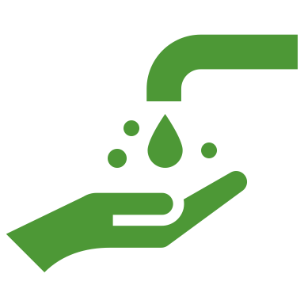

And did you know that only 3% of water exists as freshwater while the remaining amount is salt water located in our oceans?
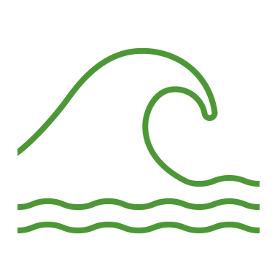

Furthermore, only 0.5% of earth’s freshwater is usable by humans since a majority is either frozen or deep underground.

This can feel overwhelming, but we can all do something about it starting right here with participants on and off our campus. We want to invite you to join our Gallon Challenge Campaign to reduce the amount of water we use daily.

Starting on (date) we will be asking participants to determine logistics on how to stay connected/organized and take on the challenge. Invite your friends and family to join!

Safety is our priority!! Please be careful when participating; do not compromise your health to participate in the Gallon Challenge. If in doubt, please ask an adult for guidance/help.

If you would like to join our Gallon Challenge Campaign, please contact:

(Project lead contact information)

