Want To Join the Gallon Challenge?
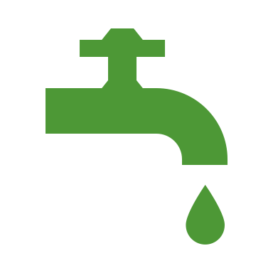
Learn about the importance of conserving water and putting it into
action by taking part in the Gallon Challenge!

Sign up here

Name | Grade | Email Address

