Want to Host a Classroom Recycling Campaign?
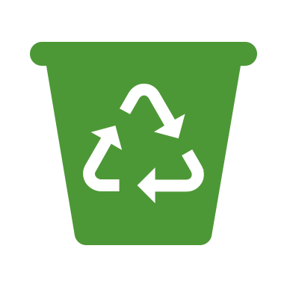
Help the environment by
joining our Classroom Recycling Campaign!

Sign up here

Name | Grade | Email Address

